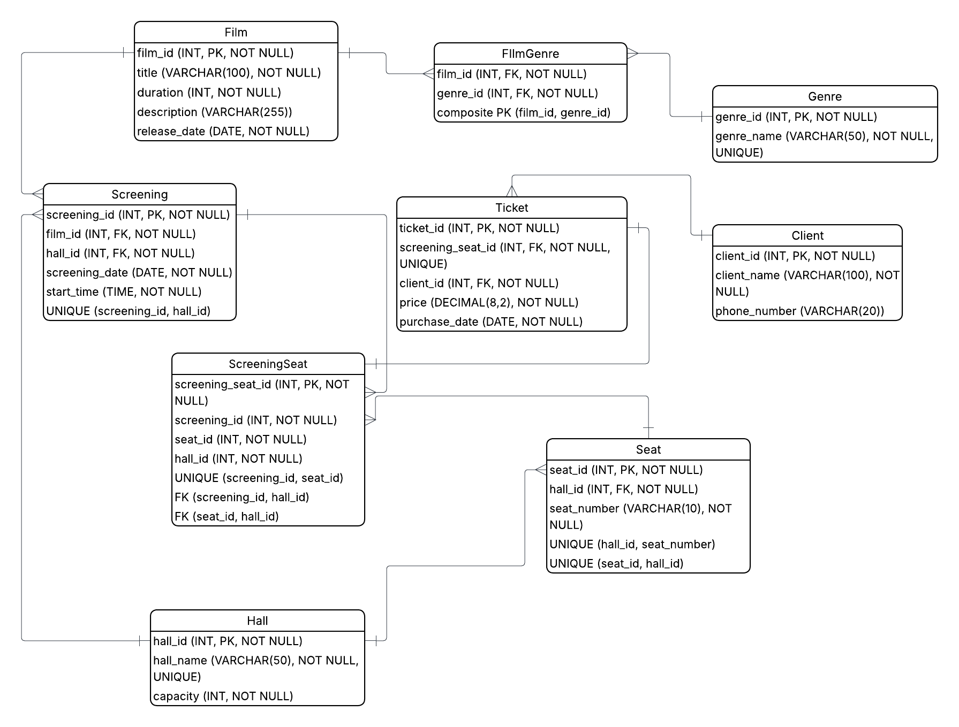
  - Logical Scheme
  - Objects
Table Name | Field name | Field Description | Data Type / Constraints
Film | film_id | Unique identifier of the film | INT, PK, NOT NULL
 | title | Title of the film | VARCHAR(100), NOT NULL
 | duration | Duration of the film in minutes | INT, NOT NULL
 | description | Short description of the film | VARCHAR(255)
 | release_date | Release date of the film | DATE, NOT NULL

Table Name | Field name | Field Description | Data Type / Constraints
Genre | genre_id | Unique identifier of the genre | INT, PK, NOT NULL
 | genre_name | Name of the genre | VARCHAR(50), NOT NULL, UNIQUE

Table Name | Field name | Field Description | Data Type / Constraints
FilmGenre | film_id | Identifier of the film linked to the genre | INT, FK, NOT NULL
 | genre_id | Identifier of the genre linked to the film | INT, FK, NOT NULL

Table Name | Field name | Field Description | Data Type / Constraints
Hall | hall_id | Unique identifier of the hall | INT, PK, NOT NULL
 | hall_name | Name of the hall | VARCHAR(50), NOT NULL, UNIQUE
 | capacity | Number of seats in the hall | INT, NOT NULL

Table Name | Field name | Field Description | Data Type / Constraints
Seat | seat_id | Unique identifier of the seat | INT, PK, NOT NULL
 | hall_id | Identifier of the hall where the seat is located | INT, FK, NOT NULL
 | seat_number | Seat number inside the hall | VARCHAR(10), NOT NULL

Table Name | Field name | Field Description | Data Type / Constraints
Screening | screening_id | Unique identifier of the screening | INT, PK, NOT NULL
 | film_id | Identifier of the film shown in the screening | INT, FK, NOT NULL
 | hall_id | Identifier of the hall where the screening takes place | INT, FK, NOT NULL
 | screening_date | Date of the screening | DATE, NOT NULL
 | start_time | Start time of the screening | TIME, NOT NULL

Table Name | Field name | Field Description | Data Type / Constraints
ScreeningSeat | screening_seat_id | Unique identifier of the screening-seat assignment | INT, PK, NOT NULL
 | screening_id | Identifier of the screening | INT, NOT NULL
 | seat_id | Identifier of the seat assigned to the screening | INT, NOT NULL
 | hall_id | Identifier of the hall used to validate seat and screening consistency | INT, NOT NULL

Table Name | Field name | Field Description | Data Type / Constraints
Client | client_id | Unique identifier of the client | INT, PK, NOT NULL
 | client_name | Full name of the client | VARCHAR(100), NOT NULL
 | phone_number | Phone number of the client | VARCHAR(20)

Table Name | Field name | Field Description | Data Type / Constraints
Ticket | ticket_id | Unique identifier of the ticket | INT, PK, NOT NULL
 | screening_seat_id | Identifier of the reserved seat for a specific screening | INT, FK, NOT NULL, UNIQUE
 | client_id | Identifier of the client who bought the ticket | INT, FK, NOT NULL
 | price | Price of the ticket | DECIMAL(8,2), NOT NULL
 | purchase_date | Date when the ticket was purchased | DATE, NOT NULL

Comments on table relationships
- Movie → Screening (1:N)
- Theater → Hall (1:N)
- Hall → Seat (1:N)
- Hall → Screening (1:N)
- Customer → Reservation (1:N)
- Reservation → Ticket (1:N)
- Screening → Ticket (1:N)
- Seat → Ticket (1:N)
- Reservation → Payment (1:1)
Many-to-Many example:
Customer ↔ Screening through Reservation + Ticket tables.

movie_id | title | genre | duration | release_date
1 | Avengers | Action | 143 | 2012-05-04
2 | Titanic | Drama | 195 | 1997-12-19

